# CitiBike_Analysis

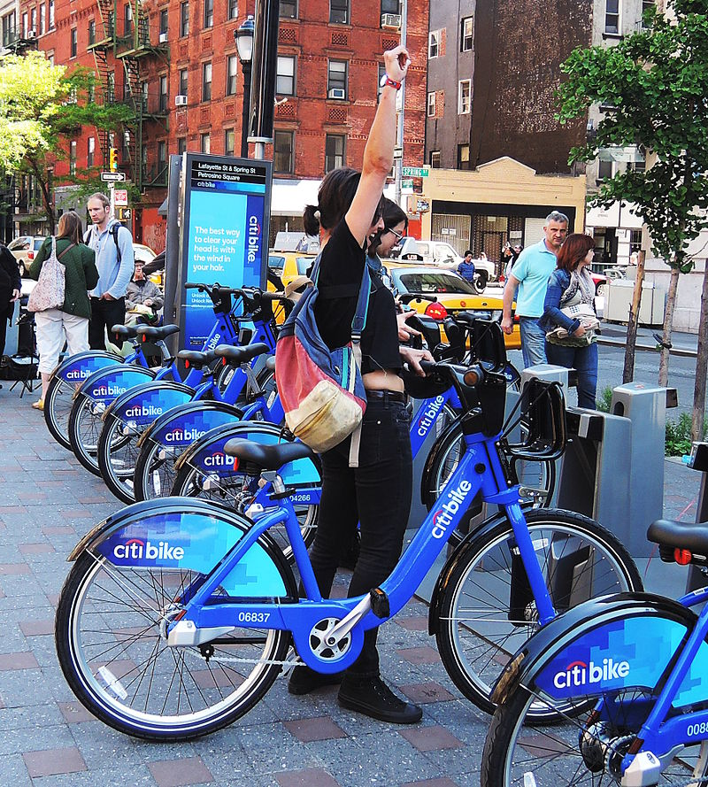

Congratulations on your new job! As the new lead analyst for the New York Citi BikeLinks to an external site. program, you are now responsible for overseeing the largest bike-sharing program in the United States. In your new role, you will be expected to generate regular reports for city officials looking to publicize and improve the city program.

Since 2013, the Citi Bike program has implemented a robust infrastructure for collecting data on the program's utilization. Each month, bike data is collected, organized, and made public on the Citi Bike DataLinks to an external site. webpage.

However, while the data has been regularly updated, the team has yet to implement a dashboard or sophisticated reporting process. City officials have questions about the program, so your first task on the job is to build a set of data reports to provide the answers.

Challenge:

Come and explore an Analysis of Citi Bike rides taken in 2023 from the months of January, February, and March!

Analysis:

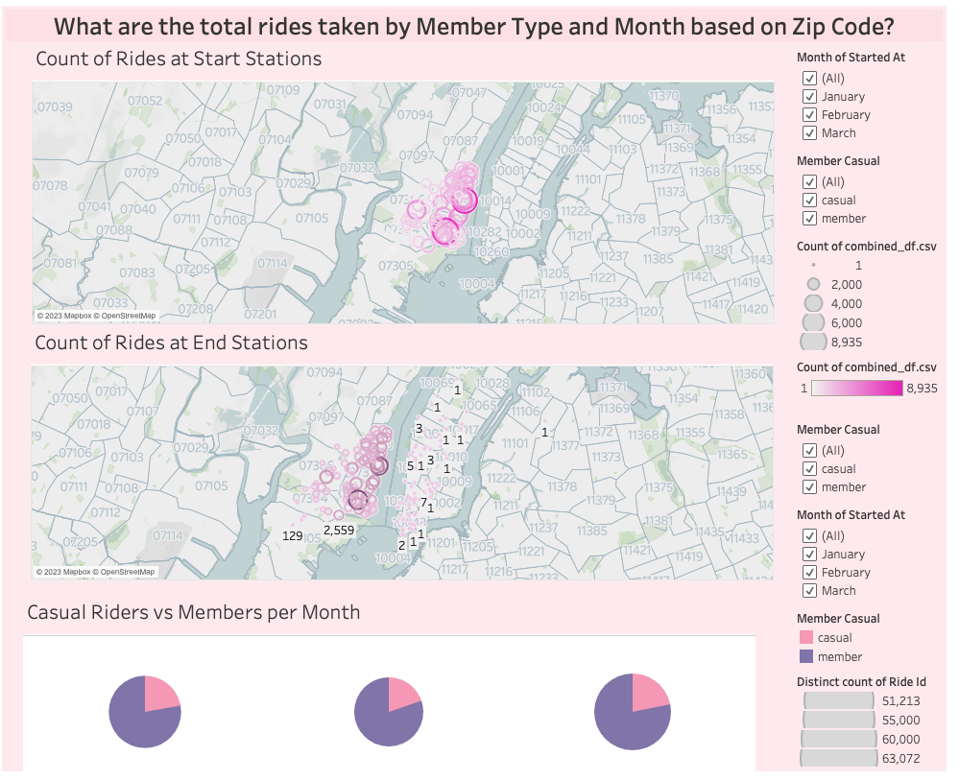

Looking at the pie chart, it is shown that the amount of people that have used Citi Bikes are members. This data shows the types of riders by the month of January, February, and March. The zip codes with the most rides taken are around 07030, 07310, and 07302.
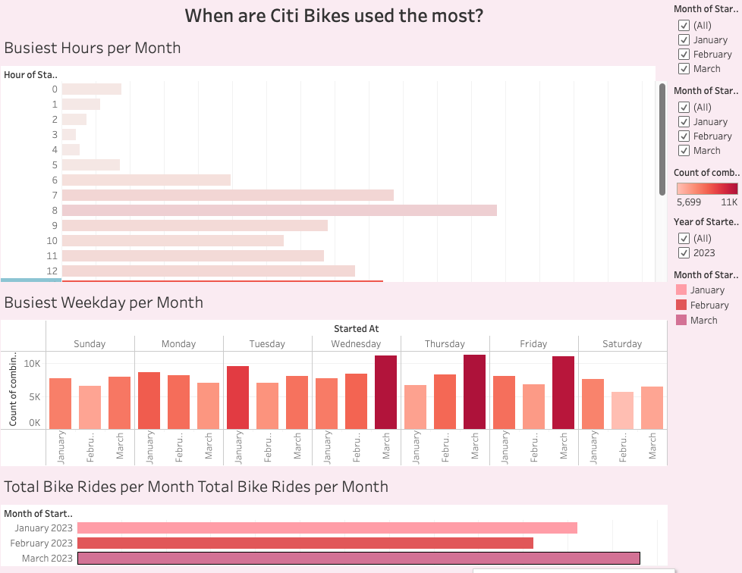

When are Citi Bikes used the most? According to our data shown, the busiest time of 5 pm and 6 pm with a total of 16,542 rides taken at 5 pm and a total of 16,229 rides taken at 6 pm for the 3 months shown. Monday and Friday were the busiest day for January, Wednesday and Thursday was the busiest day for February, and Wednesday and Thursday were the busiest days for the month of March. Overall March seemed to be the busiest month with a total of 63,072 rides taken.
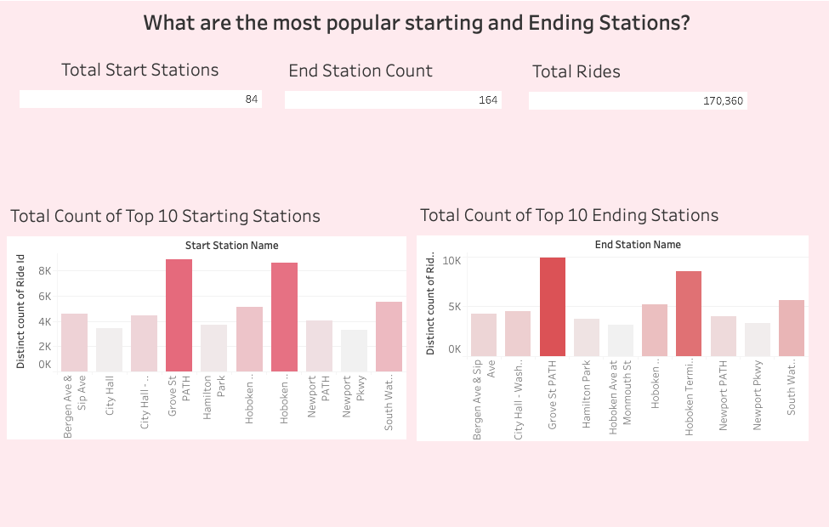

What are the most popular starting and ending stations? Based on the charts, Grove st. was the most popular starting and ending station. With a total of 84 starting stations and 164 ending stations and 170,360 total rides.

